Project Proposal

Student Grade & Result Generator

C++ project

Group Members
Fatima Rahman
Aqsa Fatima
Hurain Asad

Programing Fundamental

Dr. Muhammad Kazim

Objective
The main objective of this project is to simplify the process of evaluating students’ academic performance. By entering marks of each subject, the program will automatically calculate:
- Total marks
- Percentage
- Grade (A, B, C, D, F)
- Pass/Fail status

Scope
The scope of this project includes:
- Easy to Use: Teachers or students can input marks without needing complex software knowledge.
- Automated Result Generation: Calculates total marks, percentage, grade, and pass/fail status automatically..
- Digital Result Card: Generates a formatted result card that can be printed or saved.
Implementation Details
• Programming Language:
The project is developed in C++, which is a powerful and efficient language for implementing logical operations, calculations, loops, and functions. It is suitable for student result processing systems.

• Programming Approach:
The program follows modular programming, where the logic is divided into small user-defined functions for percentage, grade, and GPA calculation. This improves readability and reusability of the code.

• Operators:
• Arithmetic operators (+, *, /) are used to calculate total marks and percentage.
• Assignment operators (= , +=) are used to store and update values.
• Comparison operators (>=, <) are used to assign grades, calculate GPA, and determine pass or fail status.
• Ternary operator (?:) is used for concise pass/fail checking.

• Loops:
• A for loop is used to repeatedly take subject names, obtained marks, and total marks for multiple subjects.
• The loop also helps in calculating the overall obtained marks and total marks.

• Variables and Data Types:
• int data type is used for roll number, number of subjects, obtained marks, and total marks.
• float data type is used for percentage and GPA to handle decimal values.
• string data type is used to store student and subject names.

• Functions:
• User-defined functions are used to calculate:
- Percentage
- Grade
- GPA
• These functions make the program modular and easy to maintain.

• Conditional Statements:
• If statements are used to assign grades and GPA based on percentage.
• Conditional logic is also used to determine whether the student has passed or failed.

• Input and Output Handling:
• cin and getline() are used to take input from the user.
• cout is used to display the result card on the screen in a clear and readable format.

• Output Formatting:
• The final output is displayed as a structured student result card, showing total marks, percentage, grade, GPA, and pass/fail status for better readability.

Algorithm
• Start.
• Input student name, roll number, and number of subjects.
• Initialize total obtained marks = 0, total max marks = 0.
• For each subject:
- Input subject name, obtained marks, and total marks.
- Add to totals.
• Calculate percentage.
• Assign grade and GPA using if–else.
• Check pass/fail.
• Display result card.
• End.

Pseudocode
START
Input student name, roll number, number of subjects
Set totalObtained = 0
Set totalMarks = 0

For each subject
Input subject name
Input obtained marks
Input total marks
Add obtained marks to totalObtained
Add total marks to totalMarks
End For

Calculate percentage = (totalObtained / totalMarks) * 100
Assign grade and GPA based on percentage
If percentage >= 40 then status = PASS else status = FAIL

Display all results
END

Flowchart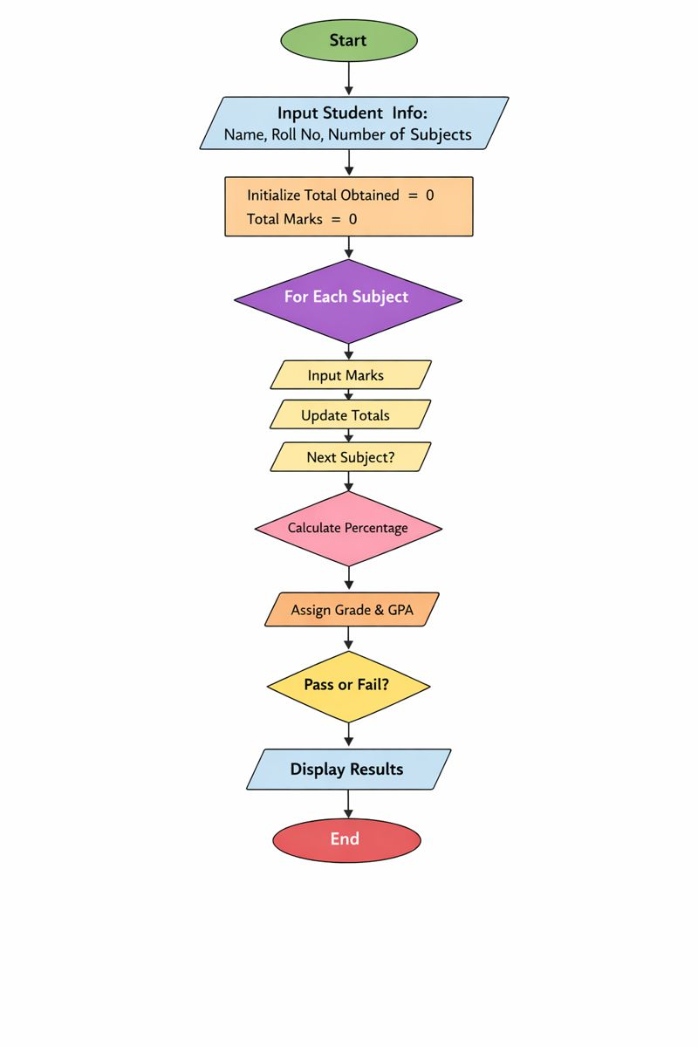

C++ Code
#include <iostream>
#include <string>
using namespace std;

float percent(int o, int t) { return o * 100.0 / t; }

string grade(float p) {
if (p >= 90) return "A+";
if (p >= 80) return "A";
if (p >= 70) return "B";
if (p >= 60) return "C";
return "F";
}

float gpa(float p) {
if (p >= 90) return 4.0;
if (p >= 80) return 3.7;
if (p >= 70) return 3.0;
if (p >= 60) return 2.0;
return 0.0;
}

int main() {
string name, sub;
int roll, n, m, max, O = 0, T = 0;

cout << "Name: "; getline(cin, name);
cout << "Roll: "; cin >> roll;
cout << "Subjects: "; cin >> n;
cin.ignore();

for (int i = 1; i <= n; i++) {
cout << "\nSubject " << i << " name: ";
getline(cin, sub);

cout << "Marks obtained: ";
cin >> m;

cout << "Out of: ";
cin >> max;
cin.ignore();

O += m;
T += max;
}

float p = percent(O, T);

cout << "\n===== RESULT =====\n";
cout << "Total: " << O << "/" << T << endl;
cout << "Percentage: " << p << "%\n";
cout << "Grade: " << grade(p) << endl;
cout << "GPA: " << gpa(p) << endl;
cout << "Status: " << (p >= 40 ? "PASS" : "FAIL") << endl;

return 0;
}
Conclusion
- Reduces manual errors
- Quick result generation
- Easy for teachers and students

( Thank you)

